Problem 1. Find classification rules in the table below.
Car | Price | Mileage | Size | Accident | d
1 | * | * | {full} | {doors, engine} | good
2 | {low} | * | {full} | {engine} | good
3 | * | {high} | {compact} | * | poor
4 | {high} | {low} | * | {doors} | good
5 | * | * | {full} | {doors} | excel
6 | {low} | {high} | {compact} | * | poor

Solution:
Tolerance Classes New Decision Column D
T(1)={1,2, 4,5} D(1)={good, excel}
T(2)={2,1} D(2)={good}
T(3)={3,6} D(3)={poor}
T(4)={4,1,5} D(4)={good, excel}
T(5)={5.1,4} D(5)={excel, good}
T(6)={6,3} D(6)={poor}

Table with a new decision column D
Car | Price | Mileage | Size | Accident | D
1 | * | * | {full} | {doors, engine} | good, excel
2 | {low} | * | {full} | {engine} | good
3 | * | {high} | {compact} | * | poor
4 | {high} | {low} | * | {doors} | good, excel
5 | * | * | {full} | {doors} | good, excel
6 | {low} | {high} | {compact} | * | poor

Discernibility Matrix for the new table with decision D
 | 1 | 2 | 3 | 4 | 5
2 | Empty
3 | S | S
4 | - | P, A | M
5 | - | A | S | -
6 | S | S | - | P, M | S

Looking for reducts (find discernibility function F):
F(P,M,S,A)= S*S*Empty*(P+A)*A*M*(P+M)= Empty /reduct – the whole set of attributes/

Looking for object reducts (Find discernibility function F for each object):
F(1)=Empty*S = Empty , F(2)=Empty*S(P+A)AS = Empty, F(3) = SM,
F(4)=(P+A)M(P+M)=(P+A)M= PM+AM
F(5)=AS, F(6)=S(P+M)= SP + SM

Rules:
For F(3) and F(6): (Size,Compact) ^ (Milage, High) -> poor sup=2
For F(4): (Price,high)^(Mileague, low) -> Good or Excel
For F(4): (Mileague,low)^(Accident,doors)-> Good or Excel
For F(5): (Size, full)^ (Accident,doors) -> Good or Excel
For F(6): (Size,low)^(Price, low)-> poor

Problem 2 (Homework). Find SVM classifier for the dataset below:
 | a | b | c
x1 | 1 | 3 | 1
x2 | 0 | 1 | 1
x3 | 2 | 2 | 0
x4 | 2 | 0 | 0

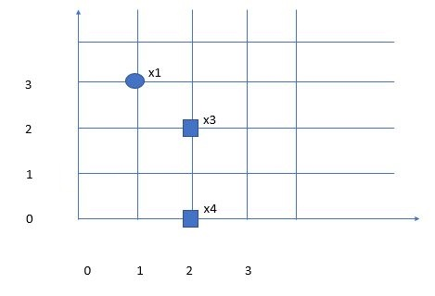

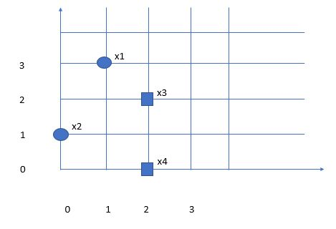

Problem 3 (Homework).
Find optimal reduct in Table T following RSH (RS Heuristic) strategy. Attribute f is the decision attribute.
 | a | b | c | d | e | f
x1 | 1 | 1 | 0 | 0 | 2 | 1
x2 | 0 | 0 | 0 | 1 | 2 | 0
x3 | 1 | 1 | 0 | 1 | 0 | 0
x4 | 1 | 0 | 0 | 2 | 0 | 0
x5 | 0 | 2 | 1 | 2 | 1 | 0
x6 | 2 | 2 | 1 | 0 | 0 | 1
x7 | 2 | 0 | 1 | 0 | 1 | 1
Table T.

Problem 4.
Follow DEAR1, DEAR2 to discover action rules reclassifying objects from class d0 to class d1 based on 6 classification rules {r1, r2,.., r6} extracted from some decision table.
5.1. Attributes a, b are stable.
5.2. Attribute a is stable
a b c d
r1 | 2 | 2 | 1 | 0
r2 | 1 | 1 | 1 | 1
r3 | 2 | 1 | 2 | 1
r4 | 1 | 3 | 1 | 0
r5 | 1 | 3 | 2 | 1
r6 | 1 | 1 | 2 | 0
Table T.

Solution (DEAR 2 algorithm).

T(a1)
b c d
r2 | 1 | 1 | 1
r4 | 3 | 1 | 0
r5 | 3 | 2 | 1
r6 | 1 | 2 | 0

T(a1, d1)
b c
r2 | 1 | 1
r5 | 3 | 2

T(a1,d0)
b c
r4 | 3 | 1
r6 | 1 | 2

a1. c1.(b3 -> b1) => (d0 -> d1) Dom={x4}
a1.b3.(c1->c2) => (d0 -> d1) Dom={x4}
a1.b1.(c2 ->c1) => (d0 -> d1) Dom={x6}
a1. c2.(b1->b3) => (d0->d1) Dom={x6}

T(a2)
b c d
r1 | 2 | 1 | 0
r3 | 1 | 2 | 1

Solution (DEAR 1 algorithm) – first split by d, follow depth-first search
Homework – finish the solution
a b c d a,b -stable
r1 | 2 | 2 | 1 | 0
r2 | 1 | 1 | 1 | 1
r3 | 2 | 1 | 2 | 1
r4 | 1 | 3 | 1 | 0
r5 | 1 | 3 | 2 | 1
r6 | 1 | 1 | 2 | 0
Table T.

T(d0)
a b c
r1 | 2 | 2 | 1
r4 | 1 | 3 | 1
r6 | 1 | 1 | 2

T(d0,a1)
b c
r4 | 3 | 1
r6 | 1 | 2

T(d0,a1,b3)
c
r4 | 1

T(d0,a1,b1)

T(d0,a2)
b c
r1 | 2 | 1

T(d0,a2,b2)
c
r1 | 1

T(d1)
a b c
r2 | 1 | 1 | 1
r3 | 2 | 1 | 2
r5 | 1 | 3 | 2

T(d1,a1)
b c
r2 | 1 | 1
r5 | 3 | 2

T(d1,a1,b1)
c
r2 | 1

T(d1,a1,b3)
c
r5 | 2

T(d0,a1,b3)
c
r4 | 1

Action Rule constructed: a1.b3.(c1 → c2) → (d0 → d1)

T(d1,a2)
b c
r3 | 1 | 2

T(d1,a2,b1)
c
r3 | 2

Problem 5
Let S=(X, {a, b, c, d}) be a decision system, where all attributes are flexible. Attribute d is the decision attribute. Find action rules reclassifying objects from the class d1 to d2 using action reducts.

 | a | b | c | d
x1 | a3 | b1 | c3 | d1
x2 | a3 | b2 | c1 | d2
x3 | a1 | b1 | c1 | d2
x4 | a2 | b1 | c1 | d1
x5 | a1 | b1 | c3 | d1
x6 | a2 | b2 | c2 | d2
System S

Solution:
 | X2 | X3 | X6
X1 | b2, c1 | a1,c1 | a2,b2,c2
X4 | a3, b2 | a1 | b2,c2
X5 | a3, b2, c1 | c1 | a2,b2,c2

Reducts for objects in the desired class (x2, x3, x6):
R(x2)= (b2+c1)(a3+b2)(a3+b2+c1)= (b2+c1)(a3+b2)= b2.a3+b2+c1.a3+c1.b2= b2+c1.a3
R(x3)= (a1+c1)a1.c1= a1.c1
R(x6)= b2 + c2
Reducts: {c1,a3}, {a1,c1}, {b2}, {c2}
Action Rules Schema:
(c, → c1).(a, → a3) → (d, d1 → d2) Dom= {x1,x4,x5}
Finding rules for that schema
b1.(c, → c1).(a, → a3) → (d, d1 → d2) Dom={x1,x4,x5}
b2.(c, → c1).(a, → a3) → (d, d1 → d2) Dom=0
Action rules schema
(a, → a1).(c, → c1) → (d, d1 → d2) Dom={x1,x4,x5}
Finding rules for that schema
b1.(a, → a1).(c, → c1) → (d, d1 → d2) Dom={x1,x4,x5}
b2.(a, → a1).(c, → c1) → (d, d1 → d2) Dom=0
a1.(b, b1→ b2) → (d, d1 → d2) Dom={x5}
a2.(b, b1→ b2) → (d, d1 → d2) Dom= {x4}
a3.(b, b1→ b2) → (d, d1 → d2) Dom={x1}
c1.(b, b1→ b2) → (d, d1 → d2) Dom= {x4}
c2.(b, -> b2) => (d, d1 -> d2)
c3.(b, b1→ b2) → (d, d1 → d2) Dom={x1,x5}

