Control Strategies for Resolution.
- Breadth-First Strategy: All of the first-level resolvents are computed first, then the second-level resolvents, and so on. An i-th level resolvent is one whose deepest parent is an (i-1)-th level resolvent. The strategy is complete.
- Set-of-Support Strategy: At least one parent of each resolvent is selected from among the clauses resulting from the negation of the goal or from their descendants (set of support). The strategy is complete.
- The Unit-Preference Strategy: The same as set-of-support but we try to select a single-literal clause to be a parent in a resolution. The strategy is complete.
- The Linear-Input Form Strategy: Each resolvent has at least one parent belonging to the base set. The strategy is not complete.
- The Ancestry-Filtered Form Strategy: Each resolvent has a parent that is either in the base set or that is an ancestor of the other parent. The strategy is complete.

Problem 1.
Knowledge Base
Whoever can read is literate: (∀x)[R(x) -> L(x)]
Dolphins are not literate: (∀x)[D(x) -> ~L(x)]
Some dolphins are intelligent: (∃x)[D(x) ^ I(x)]
Prove that: Some who are intelligent cannot read: (∃x)[I(x) ^ ~R(x)] ???

Breath First Strategy

~R(x) v L(x) ~D(x)v ~L(x) D(A) I(A) ~I(x) v R(x)

~R(x)v ~D(x) ~L(A) R(A) L(x)v ~I(x)

~I(x)v ~D(x) ~R(A) L(x) ~D(A)

~D(x) NIL

Set-of-Support Strategy (clauses marked by red form set of support)

~R(x) v L(x) ~D(x)v ~L(x) D(A) I(A) ~I(x) v R(x)

~R(x)v ~D(x) ~L(A) R(A) L(x)v ~I(x)

~I(x)v ~D(x) ~R(A) L(A) ~D(A) ~I(A)

~D(x) NIL

The Ancestry-Filtered Form Strategy (?)

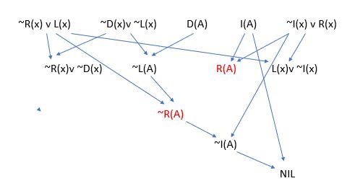

Example of Ancestry-Filtered Form Strategy (using Merge) PROLOG

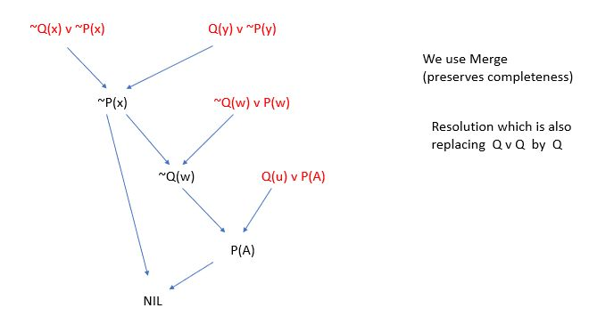

Problem 2
Consider the following facts:
- Every child loves anyone who gives the child any present.
- Every child will be given some present by Santa if Santa can travel on Christmas eve.
- It is foggy on Christmas eve.
- Anytime it is foggy, anyone can travel if he has some source of light.
- Any reindeer with a red nose is a source of light.

Prove that: If Santa has some reindeer with a red nose, then every child loves Santa.

Alphabet: child(x) – x is a child, loves(x,y) – x loves y, gives (x,y) – x gives y a present, travel(x) – x can travel on Christmas, Foggy – foggy on Christmas Eve, has(x, y)- x has y,
SL-source of light, RRN- reindeer with a red nose.

Knowledge Base:
[gives(x,y) ^ child(y)] -> loves(y,x)
[travel(Santa) ^ child(y)] -> gives(Santa, y)
Foggy
Foggy ^ has(x,SL) -> travel(x)
has(x, RRN) -> has(x, SL)
Prove: has(Santa, RRN) ^ child(y) -> loves(y, Santa) ????

Clauses
~gives(x,y) v ~child(y) v loves(y,x)
~travel(Santa) v ~child(y) v gives(Santa, y)
Foggy
~Foggy v ~has(x,SL) v travel(x)
~has(x, RRN) v has(x, SL)
Prove: ~has(Santa, RRN) v ~child(y) v loves(y, Santa)

Clauses
- ~gives(x,y) v ~child(y) v loves(y,x)
- ~travel(Santa) v ~child(y3) v gives(Santa, y3)
- Foggy
- ~Foggy v ~has(x2,SL) v travel(x2)
- ~has(x1, RRN) v has(x1, SL)
- has(Santa, RRN)
- child(y1)
- ~loves(y2, Santa)

Resolution
(9)=(3)+(4): ~has(x2,SL) v travel(x2)
(13)=(1)+(7): ~gives(x,y) v loves(y,x)
(10)=(13)+(8): ~gives(Santa,y)
(14)=(10)+(2): ~travel(Santa) v ~child(y3)
(11)=(14)+(7): ~travel(Santa)
(12)=(5)+(6): has(Santa, SL)
(15)=(9)+(12): travel(Santa)
(15)+(11): NIL

Resolution (what kind of resolution strategy?)

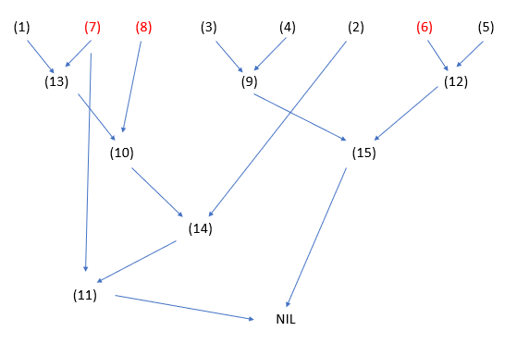

Problem. Convert to the set of clauses:
(∃z)[(∃x)Q(x, z) → (∃x)P(x)] → ¬{¬(∃x)P(x) → (∀x)(∃z)Q(z, x)}
(∀z)[(∃x)Q(x, z) ^ (∀x)~P(x)] v {~(∃y)P(y) ^ ~(∀w)(∃s)Q(s, w)}
[Q(x(z), z) ^ ~P(t)] v [~P(y) ^ ~Q(s, w(y))] .

