Cloudera setup in Virtual Box for Windows
Group Activity 01

In this activity, you are going to setup a virtual environment for running Hadoop MapReduce code , run simple commands , create a file , search through the file .
Setup Hadoop Virtual Environment
To setup a single node cluster, on your laptop , you need following software:
- Oracle Virtual Box – software to install one or more virtual machines. Get this software from https://www.virtualbox.org/
- Cloudera VM – this software acts as a virtual machine. By default, Cloudera consist of packages of most of the cloud computing frameworks like Hadoop, Spark, Hive, Pig, etc. Download Cloudera QuickStart VM for Virtual Box platform. Go get this software, go to http://www.cloudera.com/ Select Get Started Select Try Now Select Download Now inside QuickStarts box Select a platform as Virtual Box. Fill a form that pops up after this step and download Cloudera.
(or)

You can install the Cloudera from following link:

https://downloads.cloudera.com/demo_vm/virtualbox/cloudera-quickstart-vm-5.12.0-0-virtualbox.zip

Please follow the below steps to import the cloudera vmdk file to your local machine through Virtual Box or you can follow a video from the following link to install Cloudera and Virtual Box:
https://www.youtube.com/watch?v=BeCtjd86YXo

Step1: Open the Oracle Virtual Box:
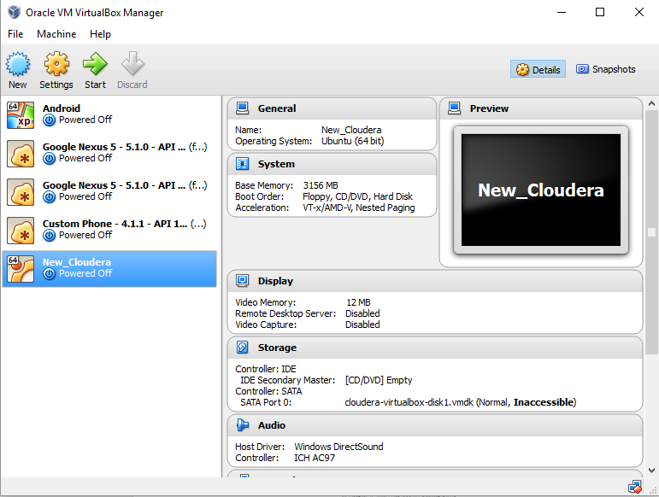
Step2: Click New in the top left corner
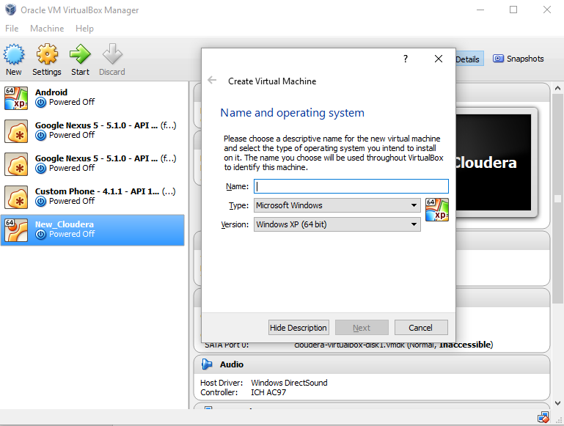

Step3: Give a name for your cloudea virtual machine and select type as ‘Linux’ and version as ‘Other Linux (64-bit) and click Next
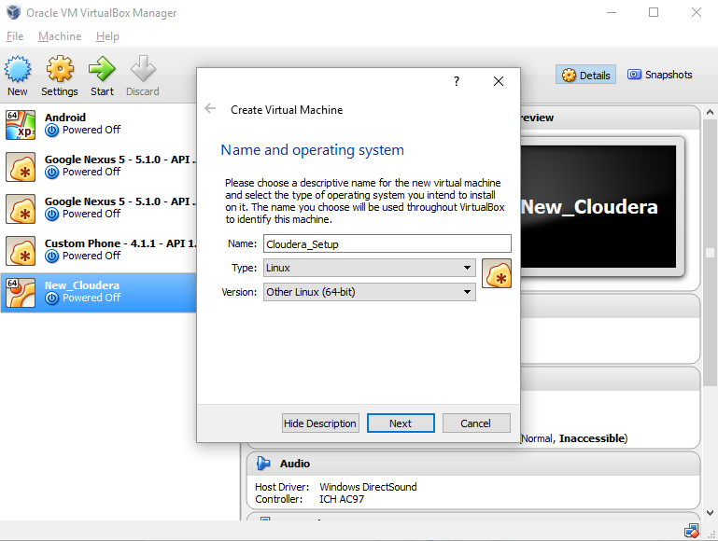
Step4: Give atleast 4096 MB of memory and click Next
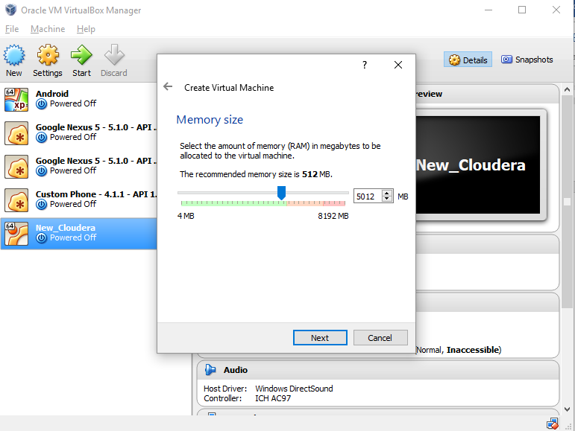

Step5: Select the option use an existing virtual hard disk file and click the browse link and then Browse and select the downloaded vmdk file, click open and click on create.
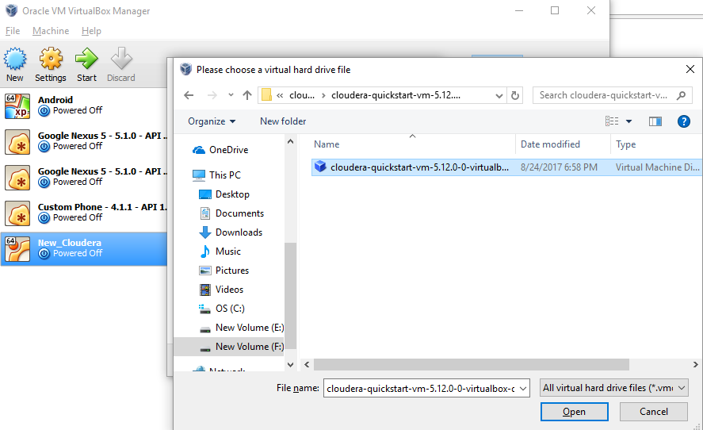

Step6: Ensure the settings are similar to the below screenshots
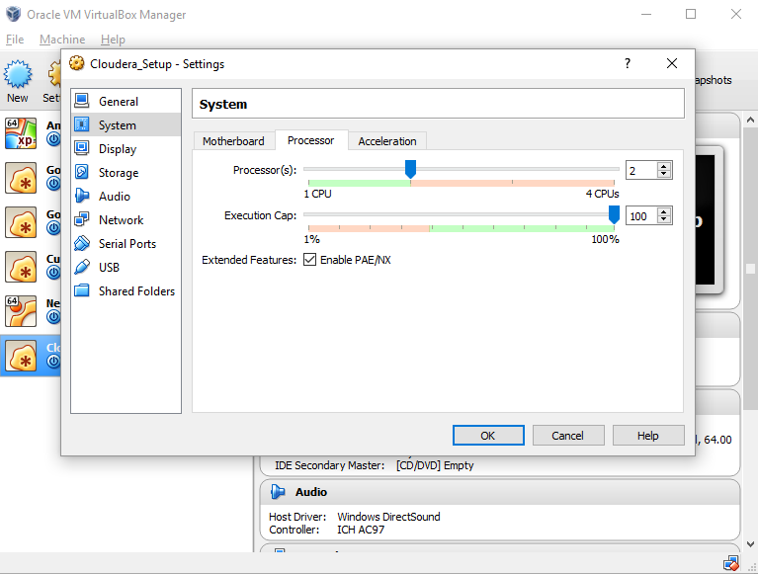
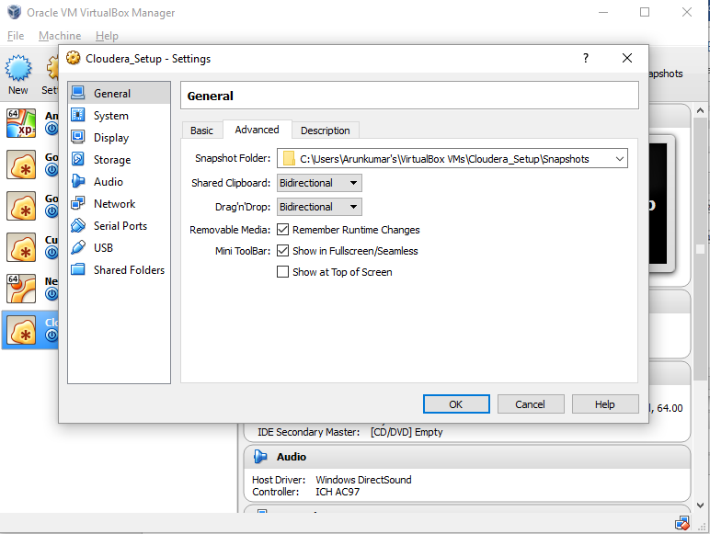
Select the virtual machine and click Start. Wait for all configurations to setup.
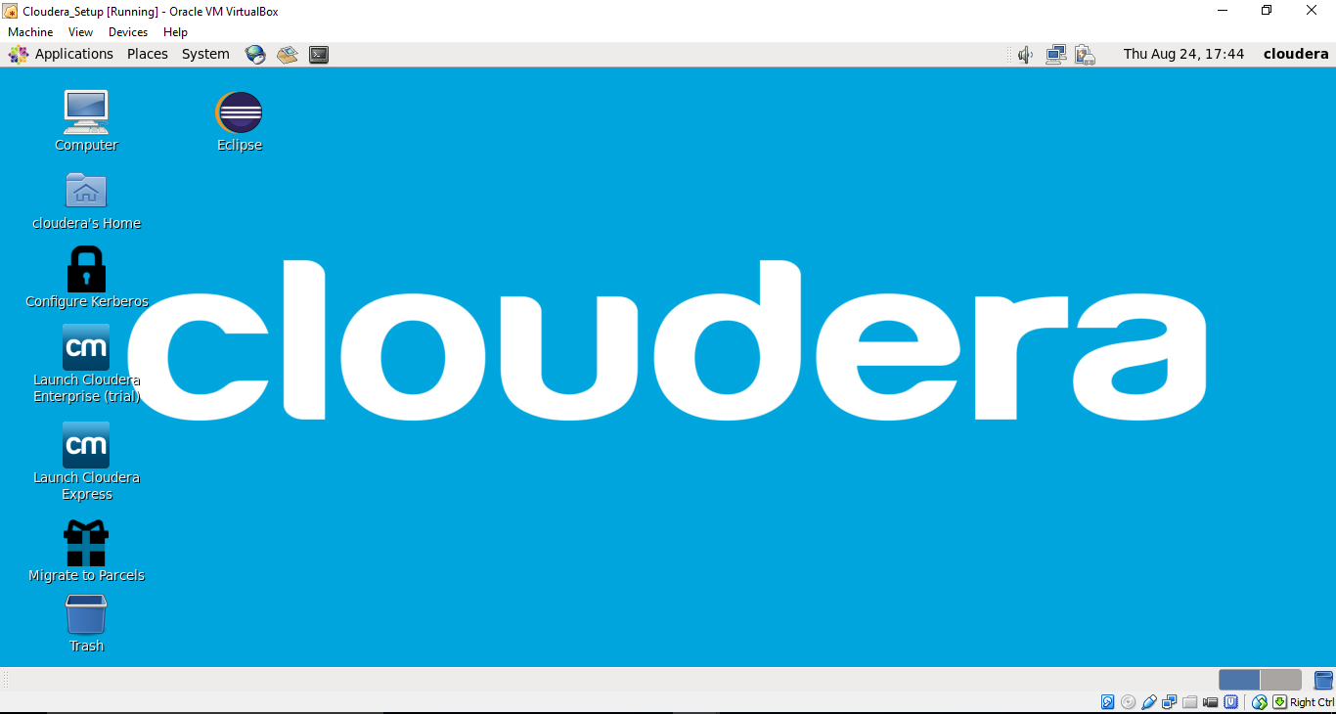
Fixing BIOS problem while installing Cloudera:
- In case of BIOS error in Windows environment enable PAE/NX, and check if issue is resolved.
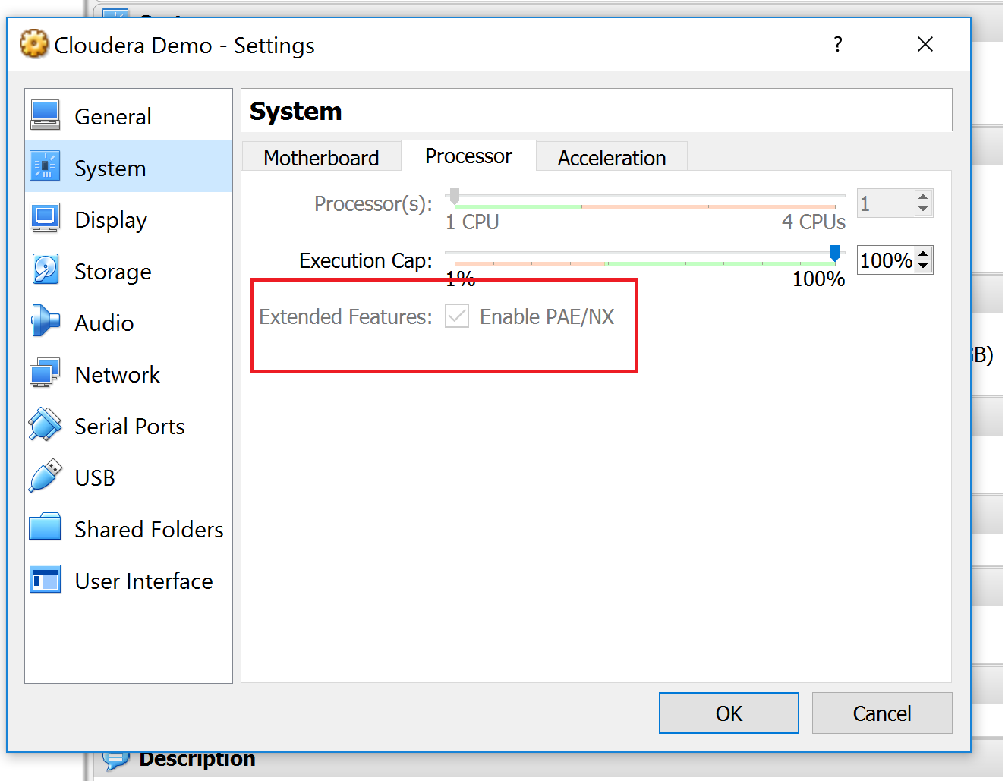

- If issue still exists, Restart computer go to bios settings and enable virtualization technology as shown in below video.

https://www.youtube.com/watch?v=-Wa7TGjmn5M
To access BIOS settings in Windows 10
1. Navigate to settings. You can get there by clicking the gear icon on the Start menu.
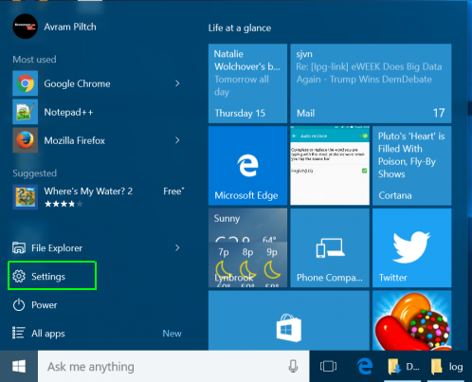
2. Select Update & security.
Advertisement
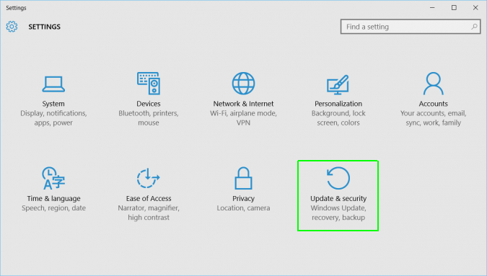
3. Select Recovery from the left menu.
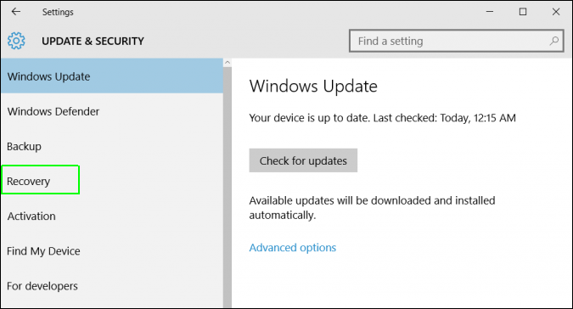
4. Click Restart Now under Advanced startup. The comptuer will reboot to a special menu.
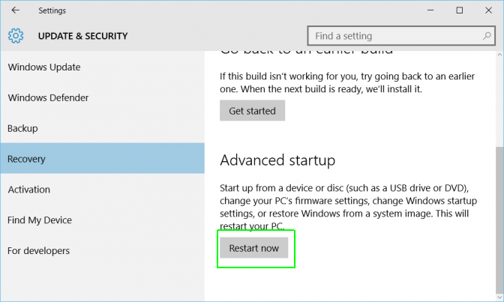
5. Click Troubleshoot.
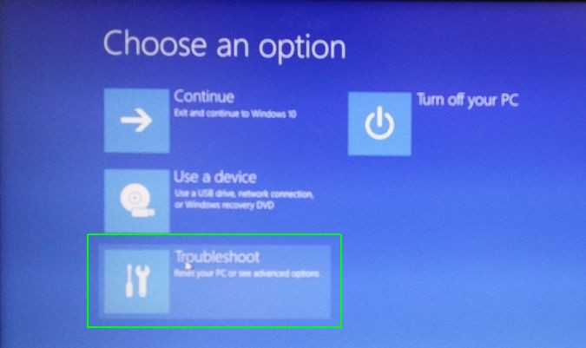
6. Click Advanced options.
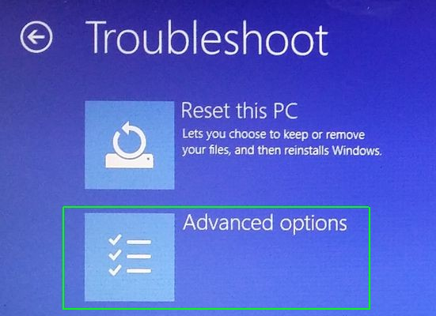
7. Select UEFI Firmware Settings.
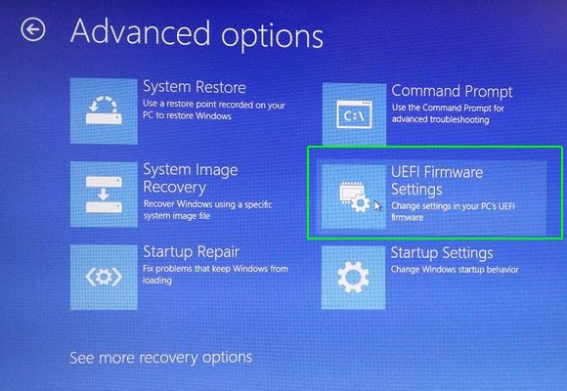
8. Click Restart.
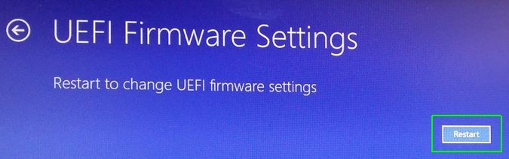
Your system will restart and take you to the BIOS.

