Tyndall Air Force Base Air Show 2014
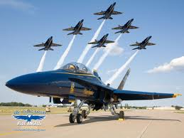
2014 Blue Angels Demonstration Team

Doors Open: 9am – 5pm Face Painting for Kids
Free Admission to the public Balloon Artists
Lawn Chairs Permitted Picnic Areas Available

www.tyndallairshow2014.com

