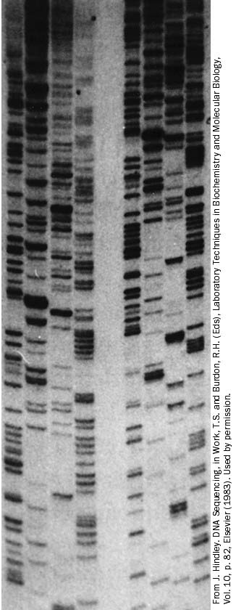

Pick one set of 4 lanes, starting at the bottom, read up in order of size (so you have to compare the 4 lanes to figure what is next) and determine the order of the nucleotides.

Is this the order of the original template or of the complementary copy?

Are there some places where you had to guess? What was the problem?

A C G T A C G T

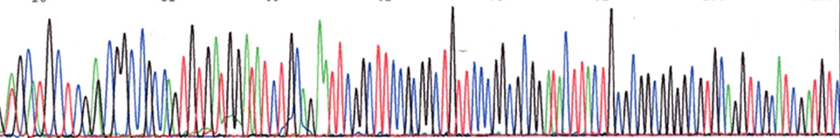

Key: Red = T, Green= A, Black = G, Blue = C

Reading from left to right, provide the DNA sequence.

Were there any bases you were not sure of and why?

What do you notice about the data – for example, are the 4 colors similar in the way they show up?

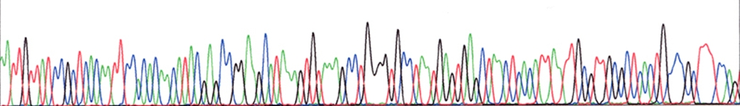

Key: Red = T, Green= A, Black = G, Blue = C

Reading from left to right, provide the DNA sequence.

Were there any bases you were not sure of and why?

What do you notice about the data – for example, are the 4 colors similar in the way they show up?

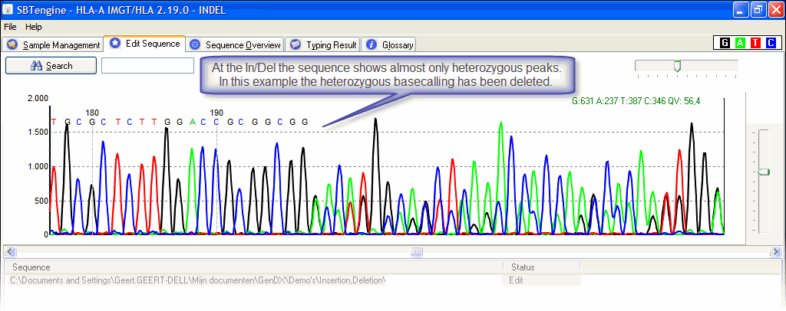

[Type a quote from the document or the summary of an interesting point. You can position the text box anywhere in the document. Use the Drawing Tools tab to change the formatting of the pull quote text box.]

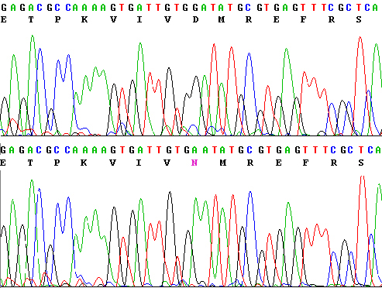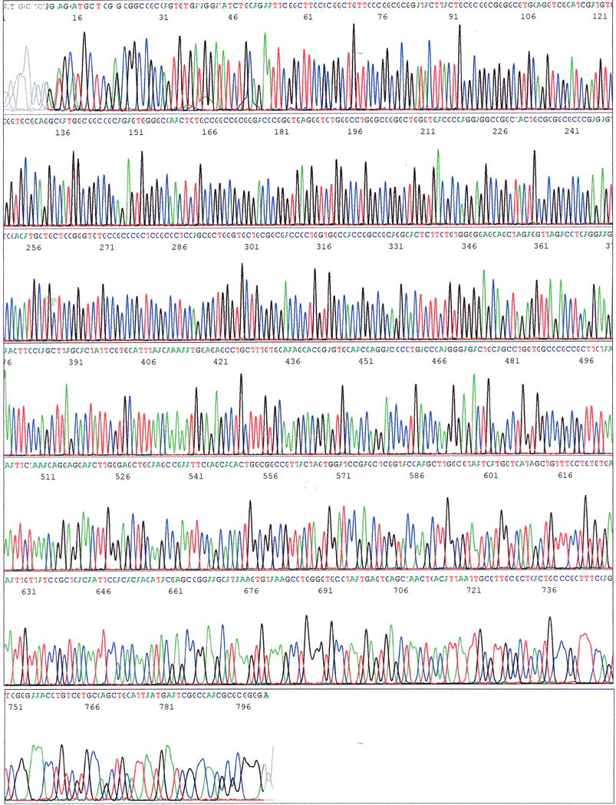

An instrument can produce 96 output files like this every 6 hours – how do you feel about reading these files by hand? Or inspecting the problem areas on each file?