FINAL SAMPLE PROBLEMS

Problem 1. Translate into symbols the following statements, using quantifiers, variables, and predicate symbols:
- A mushroom is poisonous only if it is red.
M(x) – x is a mushroom, P(x) – x is poisonous, R(x) – x is red.
(M(x) ^ P(x)) -> R(x)
- Not all white mushrooms are poisonous.
M(x) – x is a mushroom, P(x) – x is poisonous, W(x) – x is white.
~(∀x)[(M(x) ^ W(x)) -> P(x)]

- No woman likes a man who likes all vegetarians.
M(x) - x is man; W(z) – z is a woman; V(z) – z is a vegetarian (all predicates)
[M(x) -> [V(y) -> L(x,y)] -> [W(z) -> ~L(z,x)]
[[M(x) ^ V(y)] -> L(x,y)] -> [W(z) -> ~L(z,x)]
M(x) – x is a man, F(x) – x is a woman /M, F are functors/
[[V(z) -> L(M(x),z)] -> ~L(F(y), M(x))

Problem 2. Explain alpha-beta procedure using your own example with minimum 12 leaf nodes in the pruning tree. The height of the tree should be either 3 or 4.

Problem 3. In what order A*-algorithm will visit the nodes in the graph G=({s,a,b,c,d},E) assuming that s is the starting node and d is the final node. E={[s,a,3], [s,b,5], [a,b,1], [b,c,2], [b,d,5], [a,c,2], [c,d,2]} is the set of edges. We also assume that h(s)=4, h(a)=4, h(b)=3, h(c)=1, h(d)=0. Function h(x) the heuristic estimation of the distance from node x to the final node.
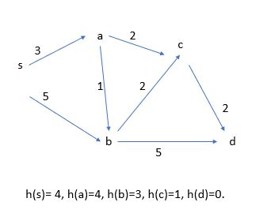
Solution (A* - monotonic + always underestimates distance to the goal state):
s->a (3+4=7)
s->b (5+3=8)
a->c ((3+2)+1=6) Not Monotonic
a->b ((3+1)+3=7)

Problem 4.
Consider the following facts:
- Every child loves anyone who gives the child any present.
- Every child will be given some present by Santa if Santa can travel on Christmas eve.
- It is foggy on Christmas eve.
- Anytime it is foggy, anyone can travel if he has some source of light.
- Any reindeer with a red nose is a source of light.

Prove that: If Santa has some reindeer with a red nose, then every child loves Santa.

To what class (Breadth-First, Set-of-Support, Unit-Preference, Linear-Input Form, Ancestry-Filtered Form) your strategy belongs? List all.

Predicates: child(x), gives(x,y), loves(x,y),
travel(x) – x can travel on Christmas Eve, has(x,y),
Foggy – foggy on Christmas Eve

Constants: SL, RRN, Santa

Statements
gives(x,y) ^ child(y) -> loves(y,x)
travel(Santa) ^ child(y) -> gives(Santa, y)
Foggy
Foggy ^ has(x,SL) -> travel(x)
has(x, RRN) -> has(x, SL)
Prove: has(Santa, RRN) ^ child(y) -> loves(y, Santa)

Clauses
- ~gives(x,y) v ~child(y) v loves(y,x)
- ~travel(Santa) v ~child(y3) v gives(Santa, y3)
- Foggy
- ~Foggy v ~has(x2,SL) v travel(x2)
- ~has(x1, RRN) v has(x1, SL)
- has(Santa, RRN)
- child(y1)
- ~loves(y2, Santa)

Resolution
(9)=(3)+(4): ~has(x2,SL) v travel(x2)
(13)=(1)+(7): ~gives(x,y) v loves(y,x)
(10)=(13)+(8): ~gives(Santa,y)
(14)=(10)+(2): ~travel(Santa) v ~child(y3)
(11)=(14)+(7): ~travel(Santa)
(12)=(5)+(6): has(Santa, SL)
(15)=(9)+(12): travel(Santa)
(15)+(11): NIL

Breadth-First (yes), Set-of-Support (no), Unit-Preference (no because not set-of-support), Linear-Input Form (no), Ancestry-Filtered Form (no)
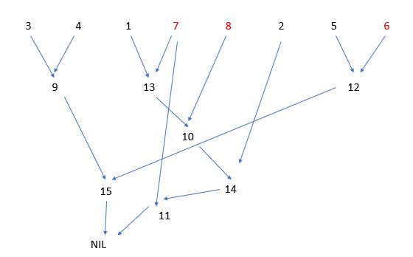

n1 – 3 (number of atomic statements in a clause 1), n2 – 3 (number of atomic statements in a clause 2), n3 – 1, n4 – 3, n5 – 2, n6 – 1, n7- 1, n8 – 1, n9 – 2, n10 – 1, n11- 1, n12 – 1, n13 – 2, n14 – 2, n15- 1

Control Strategies for Resolution.
1. Breadth-First Strategy: All of the first-level resolvents are computed first, then the second-level resolvents, and so on. An i-th level resolvent is one whose deepest parent is an (i-1)-th level resolvent. The strategy is complete.
2. Set-of-Support Strategy: At least one parent of each resolvent is selected from among the clauses resulting from the negation of the goal or from their descendants (set of support). The strategy is complete.
3. The Unit-Preference Strategy: The same as set-of-support but we try to select a single-literal clause to be a parent in a resolution. The strategy is complete.
4. The Linear-Input Form Strategy: Each resolvent has at least one parent belonging to the base set. The strategy is not complete.
5. The Ancestry-Filtered Form Strategy: Each resolvent has a parent that is either in the base set or that is an ancestor of the other parent. The strategy is complete.

Problem 5. For the information system given below, find the set of certain rules describing C in terms of E, F, G by applying Gini Index.

X | E | F | G | C
x1 | e1 | f3 | g2 | c2
x2 | e2 | f3 | g1 | c1
x3 | e2 | f3 | g2 | c1
x4 | e2 | f2 | g2 | c2
x5 | e1 | f2 | g1 | c1
System S

Solution
Gin[S]= 2/5 * 3/5 = 6/25
Gin[S,E] = 2/5*[1/2 * ½] + 3/5*[2/3 * 1/3] = 1/10 + 6/45
Gin[S,F] = 3/5*[2/3 * 1/3] + 2/5*[1/2 * 1/2] = 1/10 + 6/45
GIN[S,G] = 3/5*[2/3 * 1/3] + 2/5*[2/2 * 0]
Split S into S(g1) and S(g2) by attribute G:

X | E | F | C
x2 | e2 | f3 | c1
x5 | e1 | f2 | c1
System S(g1) rule: g1 -> c1 (with this sub-table we are done)
X | E | F | C
x1 | e1 | f3 | c2
x3 | e2 | f3 | c1
x4 | e2 | f2 | c2
System S(g2) (this one, we still need to split)

Gin(S(f3)) = 1/3 * 2/3
Gin(S(f3),E) = Gin(S(f3),F) = 1/3 * 0 + 2/3*[1/2 * ½]= 2/12 = 1/6

Split S(g2) by attribute F into S(g2,f2) and S(g2,f3):
X | E | C
x4 | e2 | c2
S(g2,f2): g2*f2 -> c2

X | E | C
x1 | e1 | c2
x3 | e2 | c1
S(g2,f3): g2*f3*e1 -> c2 ; g2*f3*e2 -> c1

Problem 6.
Convert the following formula to CNF:
¬(∀x)(∃y)[Q(x,y) ∧ ¬P(x,y)] ∨ ¬(∃y)(∀x)[Q(x,y) ∧ ¬R(x,y)].
Solution.
¬(∀x)(∃y)[Q(x,y) ∧ ¬P(x,y)] ∨ ¬(∃z)(∀w)[Q(w,z) ∧ ¬R(w,z)].
(∃x)(∀y) ¬[Q(x,y) ∧ ¬P(x,y)] ∨ (∀z)( ∃w) ¬ [Q(w,z) ∧ ¬R(w,z)].
(∃x)(∀y) [¬Q(x,y) ∨ P(x,y)] ∨ (∀z)( ∃w)[¬Q(w,z) ∨ R(w,z)].
[¬Q(A,y) ∨ P(A,y) ∨ ¬Q(w(z),z) ∨ R(w(z),z)].

Problem 7.
Convert the following formula to CNF and check if it is satisfiable:
(∃x) [¬(∀y)[p∧q ∧ ¬ r(x,y)] ∧¬s(x)] → (∀x)[q ∧ s(x)]
Solution:
(∃x) [¬(∀y)[p∧q ∧ ¬ r(x,y)] ∧¬s(x)] → (∀z)[q ∧ s(z)]
(∀x) (∀y)[p∧q ∧ ¬ r(x,y)] v s(x)] v (∀z)[q ∧ s(z)]
[[p∧q ∧ ¬ r(x,y)] ∨ s(x)] v [q ∧ s(z)]

[ A ∧ B ∧ C ] ∨ [D ∧ E]
[[p v s(x)]∧[q v s(x)]∧ [¬ r(x,y) v s(x)]] v [q ∧ s(z)]
Remark: [A ^ B ^ C] v [ D ^ E] =
[AvD] ^ [AvE] ^ [BvD] ^ [BvE]^ [CvD] ^ [CvE] - CNF

[[p v s(x)]∧[q v s(x)]∧ [¬ r(x,y) v s(x)]] v [q ∧ s(z)] - satisfiable
[ T T T ] v(q)=T , v(s(z))=T

Problem 8.

Assuming that procedure graph for the surgery P(0,1) is presented by the figure below, find the score associated with that surgery.

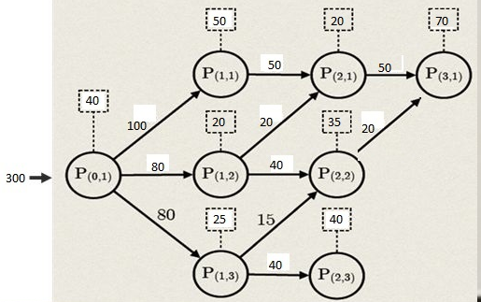

Solution:
Score(P(2,1))= [20/70]*0 + [50/70]*1 = 5/7 = 0.71
Score(P(2,2))= [35/55]*0 + [20/55]*1 = 20/55
Score(P(1,2))= [20/80]*0 + [20/80]*[1+P(2,1)] + [40/80]*[1+P(2,2)] =
2/8 * [1 + 5/7] + 4/8 * [1 + 20/55] = 2/8 * 12/7 + 1/2 * 75/55 =
24/56 + 75/110 = 0.43 + 0.68 = 1.11
Score(P(1,3))= [25/80]*0 + [15/80]*[1 + score(P(2,2))] + [40/80]*[1+0] =
15/80 * [1 + 20/55] + ½ * 1 = 15/80 * 75/55 + ½ = 3/16 * 15/11 =
45/176 = 0.26

Score(P(1,1)) = [50/100]*0 + [50/100]*[1 + score(P(2,1)] =
½ * [1 + 0.71] = 0.5 * 1.71 = 0.85
Score(P(0,1))= [40/300]*0 + [100/300]*[1+ score(P(1,1)] +
[80/300]*[1+ score(P(1,2)] + [80/300]*[1 + score(P(1,3)] =
1/3 * [1 + 0.85] + 8/30 * [1 + 1.11] + 8/30 * [1 + 0.26] =
0.33 * 1.85 + 0.27 * 2.11 + 0.27 * 0.26 = 0.61 + 0.57 + 0.07 = 1.25

