Assignment 9
Exercise 9 - Chapter 6
Fig. 6-3 shows the concept of a resource graph. Do illegal graphs exist, that is, graphs that structurally violate the model we have used of resource usage? If so, give an example of one.

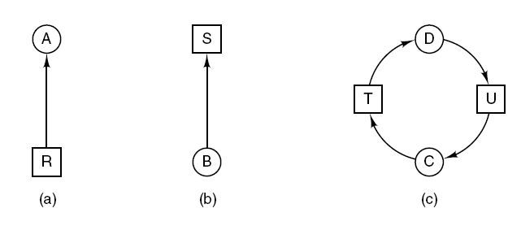
Figure 6-3. Resource allocation graphs.
(a) Holding a resource. (b) Requesting a resource. (c) Deadlock.

Exercise 39-Chapter 6
A student majoring in anthropology and minoring in computer science has embarked on a research project to see if African baboons can be taught about deadlocks. He locates a deep canyon and fastens a rope across it, so the baboons can cross hand-overhand. Several baboons can cross at the same time, provided that they are all going in the same direction. If eastward-moving and westward-moving baboons ever get onto the rope at the same time, a deadlock will result (the baboons will get stuck in the middle) because it is impossible for one baboon to climb over another one while suspended over the canyon. If a baboon wants to cross the canyon, he must check to see that no other baboon is currently crossing in the opposite direction. Write a program using semaphores that avoids deadlock. Do not worry about a series of eastward-moving baboons holding up the westward-moving baboons indefinitely.

