Assignment 7

Exercise 3 - Chapter 5

Figure 5-3(b) shows one way of having memory-mapped I/O even in the presence of separate buses for memory and I/O devices, namely, to first try the memory bus and if that fails try the I/O bus. A clever computer science student has thought of an improvement on this idea: try both in parallel, to speed up the process of accessing I/O devices. What do you think of this idea?

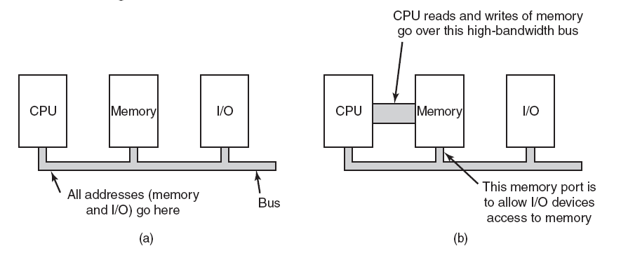
Figure 5-3. (a) A single-bus architecture. (b) A dual-bus memory architecture

Exercise 31 - Chapter 5

Disk requests come in to the disk driver for cylinders 10, 22, 20, 2, 40, 6, and 38, in that order. A seek takes 6 msec per cylinder. How much seek time is needed for

(a) First-come, first served.
(b) Closest cylinder next.
(c) Elevator algorithm (initially moving upward).

In all cases, the arm is initially at cylinder 20.

