Assignment 3
Exercise 26 - Chapter 2
In Section 2.3.4, a situation with a high-priority process, H, and a low-priority process, L, was described, which led to H looping forever. Does the same problem occur if round-robin scheduling is used instead of priority scheduling? Discuss.

Exercise 55 - Chapter 2
Consider the procedure put_forks in Fig. 2-47. Suppose that the variable state[i] was set to THINKING *after* the two calls to test, rather than before. How would this change affect the solution?

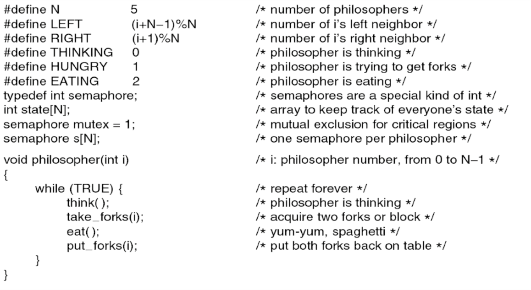
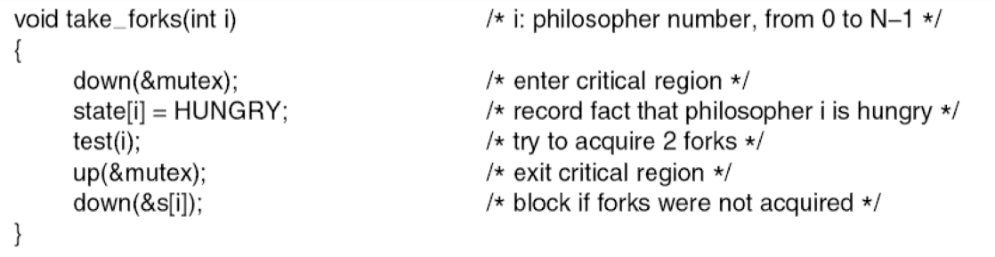
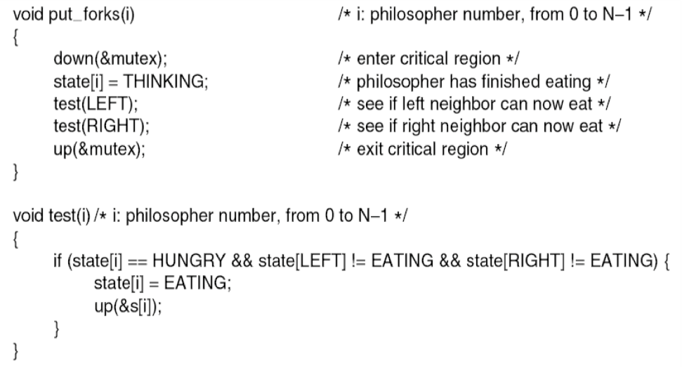
Figure 2-47. A solution to the dining philosopher’s problem.

