Assignment 2

Read Chapter 1.5 – 1.8 and Chapter 2.1 – 2.2 from the textbook today , and think about the following questions. Write your answers in a PDF format , include your name and student ID on the top , and upload to Moodle . Turn in the remaining Exercises in the same way .

Exercise 27 – Chapter 1
Modern operating systems decouple a process address space from the machine’s physical memory. List two advantages of this design.

Exercise 12 – Chapter 2
In Fig. 2-8, a multithreaded Web server is shown. If the only way to read from a file is the normal blocking read system call, do you think user-level threads or kernel-level threads are being used for the Web server? Why?
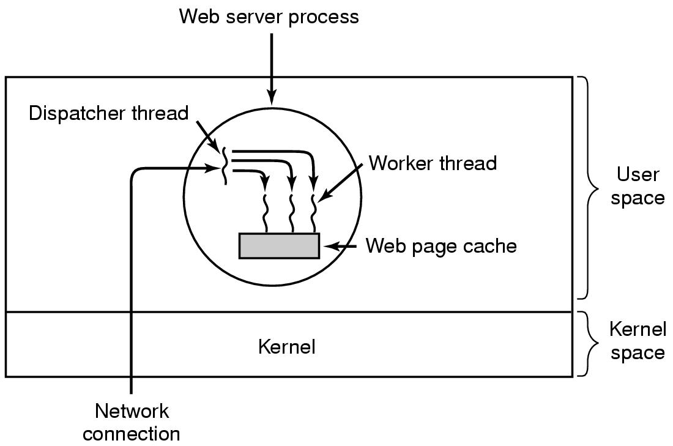
Figure 2-8. A multithreaded Web server.

